Literacy support worksheet

3.1 Water can change state

Pages 48–49 and 184

The state we’re in

1 Complete the flow chart below using Figure 3.4 in the student book to revise the states of water.

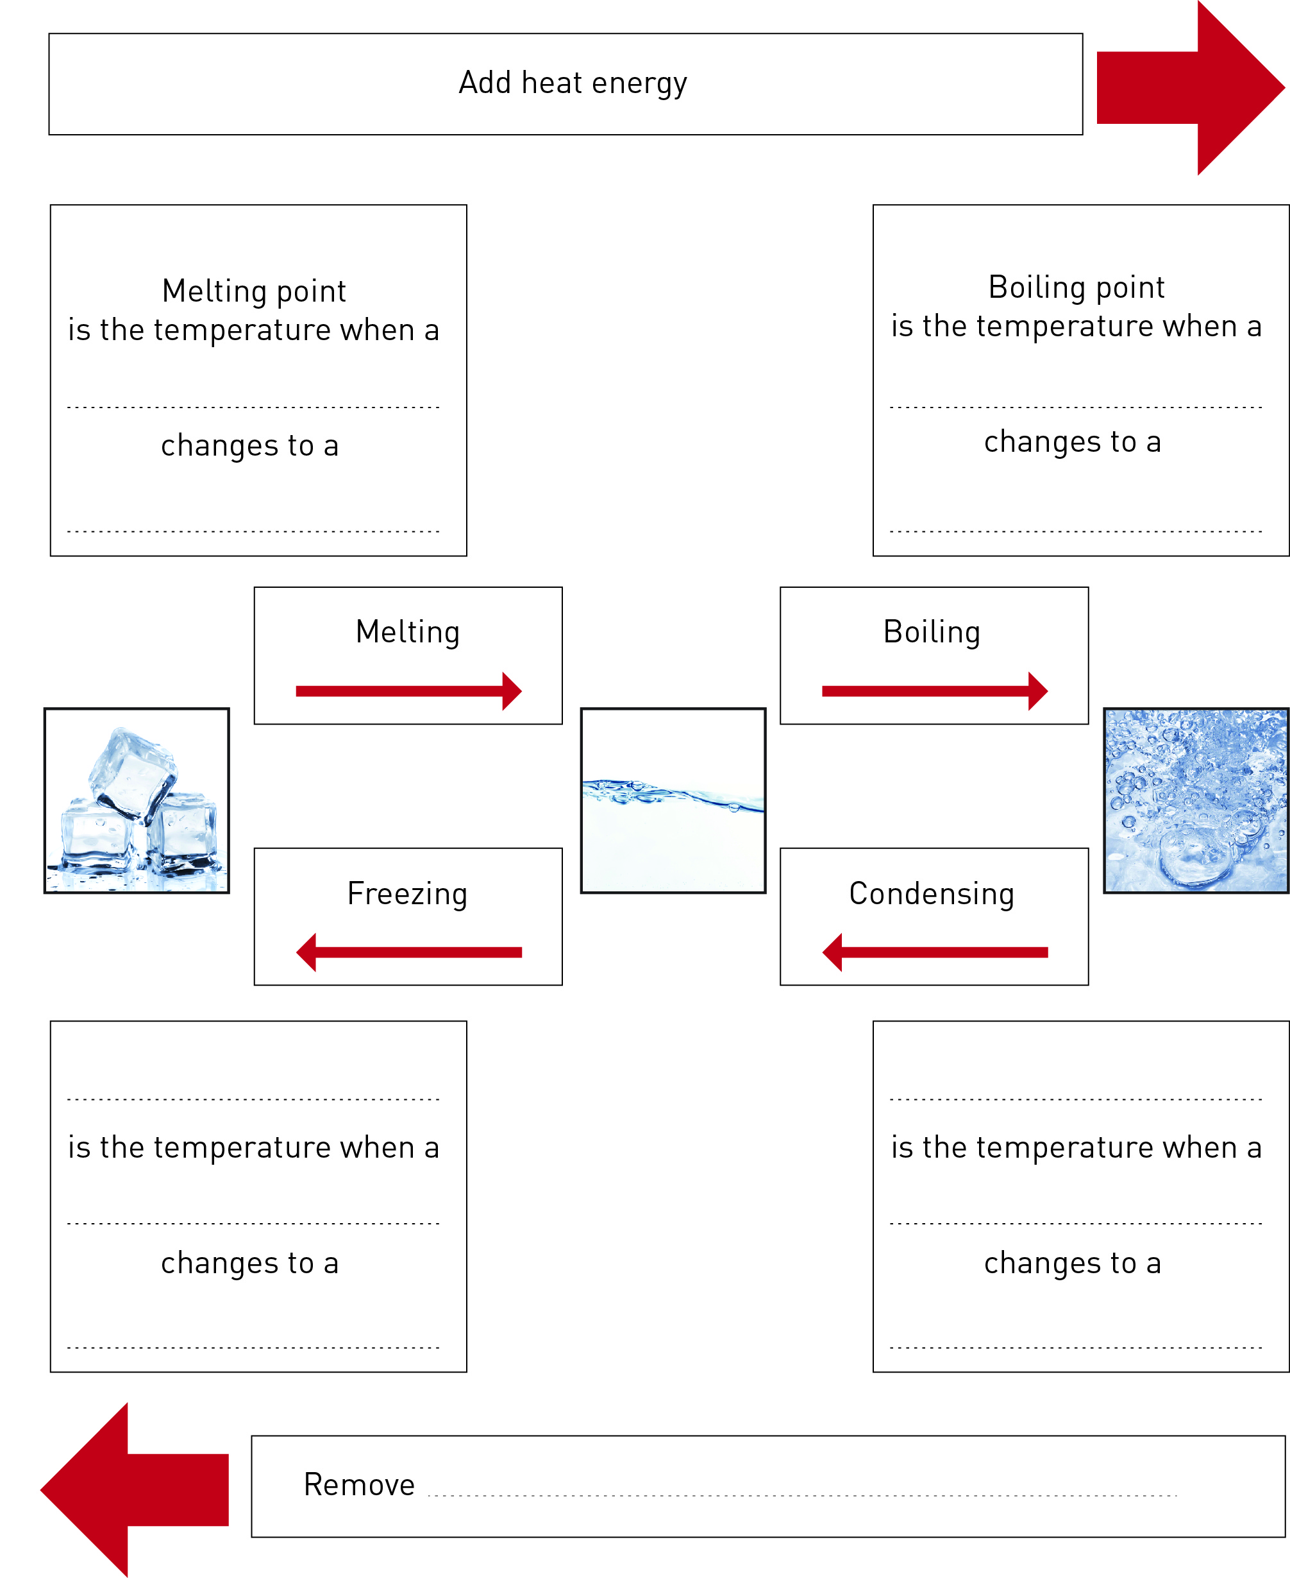

2 After completing the ‘Three States of Water’ experiment, label the diagram below to identify the *processes* causing the changes of state.

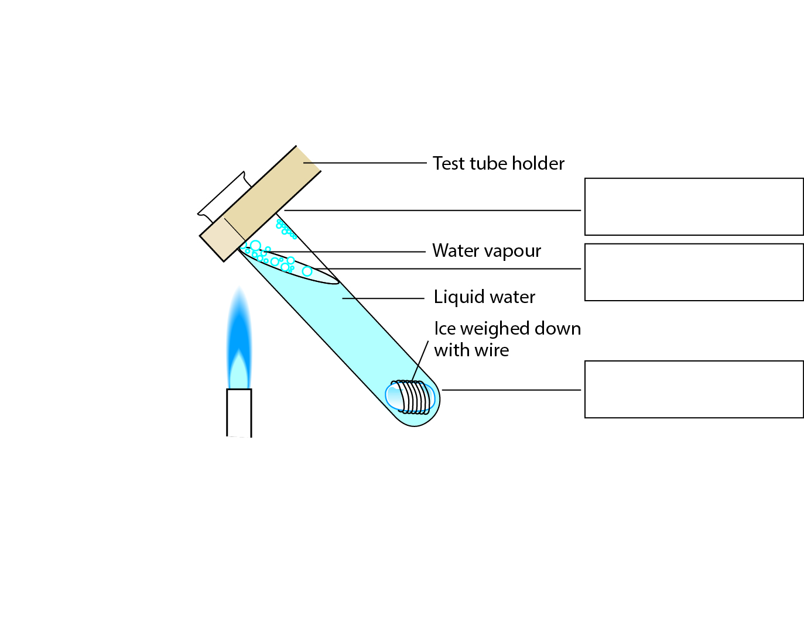

3 Fill in the state in the spaces provided belowusing the following words: *steam*, *water***,** *ice***.**

a ice + heat = ______________________________________________________

b water – heat = ______________________________________________________

c steam – heat = ______________________________________________________

d water + heat = ______________________________________________________

4 Fill in the process that leads to the change of state in the space provided.

a When you add heat to ice you are ______________ the ice.

b When you add heat to water you are _________________ the water.

c When you cool water you are ____________ it.

d When you remove heat from steam, you cause c_______________.

WORD DETECTIVE

5 Secret message

Use words from the student book to work out the secret message below:

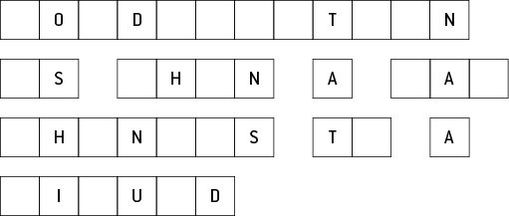

Literacy support worksheet

3.2 Water cycles through the environment

Pages 50–51 and 185

Riding with H2O – The water cycle

1 Complete the flow chart below on the water cycle.

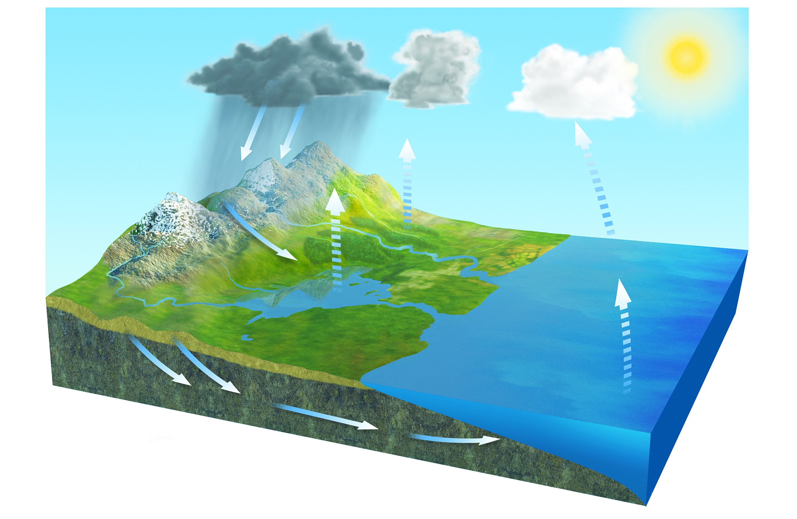

2 What does the Sun do in the water cycle?

3 Name the changes of state during the water cycle in the spaces below:

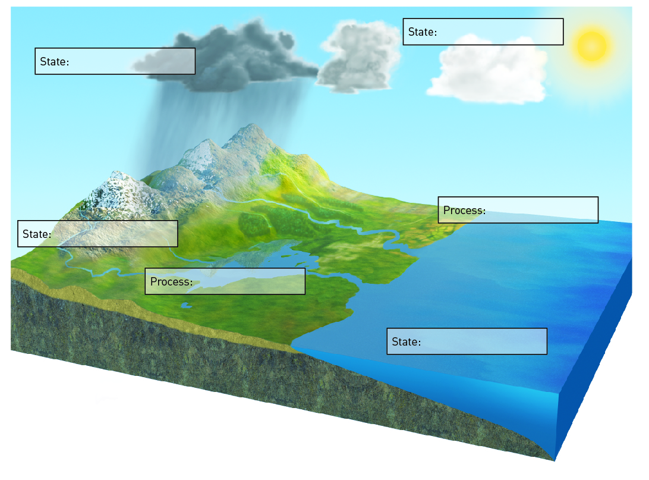

WORD DETECTIVE

4 Quick quiz

Answer the following questions using the list of words below:

condensation steam evaporated ice precipitation transpiration

a What is another name for water vapour? ________________

b When water drops form on the inside of a car, it is called: __________________.

c What is solid water called? __________________

d When you put on aftershave or perfume and it disappears, it has: _______________.

e What is the name for when the water from plants evaporates? _______________

f When clouds form water droplets and they fall to Earth, it is called: _______________.

Now design your own quick quiz for a friend.

Literacy support worksheet

3.3 Factors in nature affect the water cycle

Pages 52–53

Land of droughts and flooding rains

1 The diagram below shows the processes of El Niño. Look at the colour coding on the diagram and which states of matter exist in the air and the ocean, then fill in the boxes.

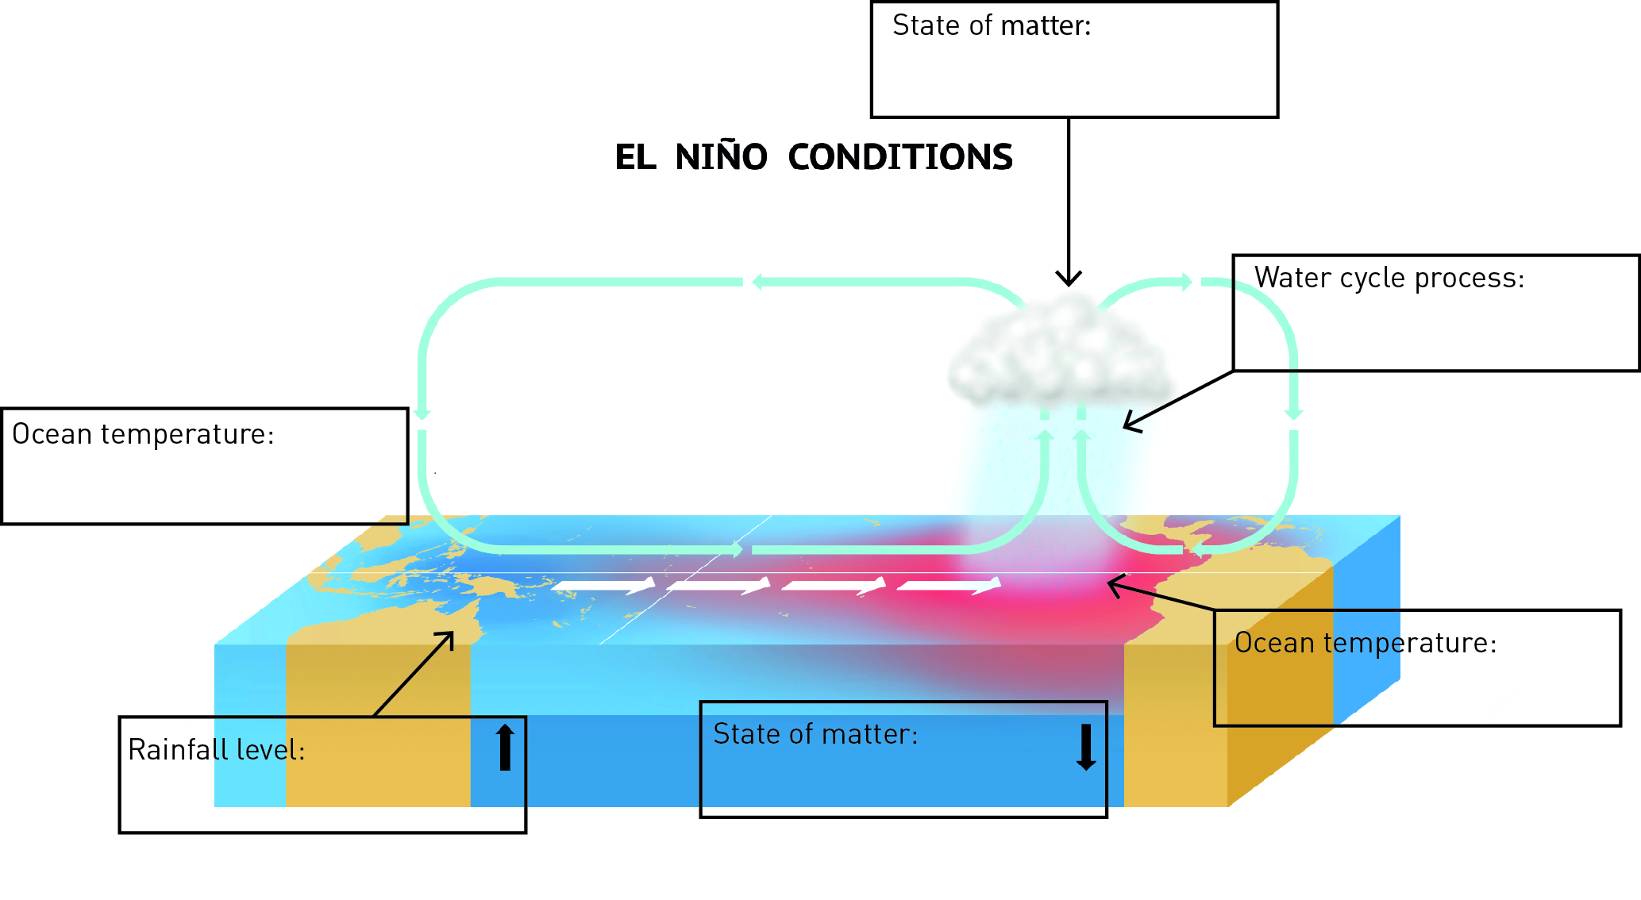

2 Describe how El Niño affects Peru. This is different to how it affects Australia.

3 Describe how La Niña affects Peru.

4 The diagram below shows the processes of La Niña. Look at the colour coding on the diagram and which states of matter exist in the air and the ocean, then fill in the boxes.

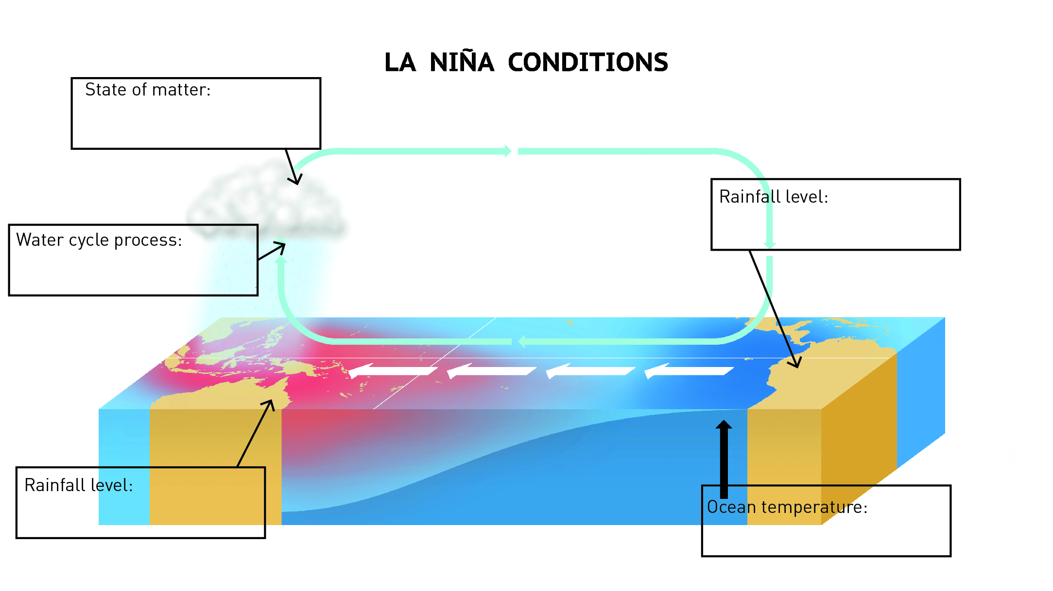

WORD DETECTIVE

5 Mumbo-jumbo

a Use the marked letters to find the secret word (e.g. olusntoi = solution).

b Unscramble each of the clue words below to find the message.

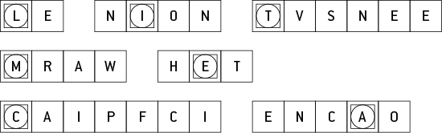

Secret word: __________________________________________________________________________

Message: ____________________________________________________________________________

Literacy support worksheet

3.4 Human management affects the water cycle

Pages 54–55 and 186

What’s the use of water?

1 Approximately 65% of the water we use in Australia is used for agriculture and farms.

a What other purposes is water used for in Australia?

b In the table below, write two pros and two cons of using water for agriculture.

|  |  |
| --- | --- |
| PROS of using water for agriculture | CONS of using water for agriculture |
|  |  |
|  |  |
|  |  |

2 Industry causes the emission of pollution as a result of the burning of fossil fuels. This pollution has been linked to changes in weather patterns and global warming. If pollution from burning fossil fuels mixes with the water vapour in the clouds, it can cause acid rain. How can acid rain affect humans, dams and plants?

3 The Thomson Dam and the Warragamba Dam are marked on the cropped image from the map in the textbook.

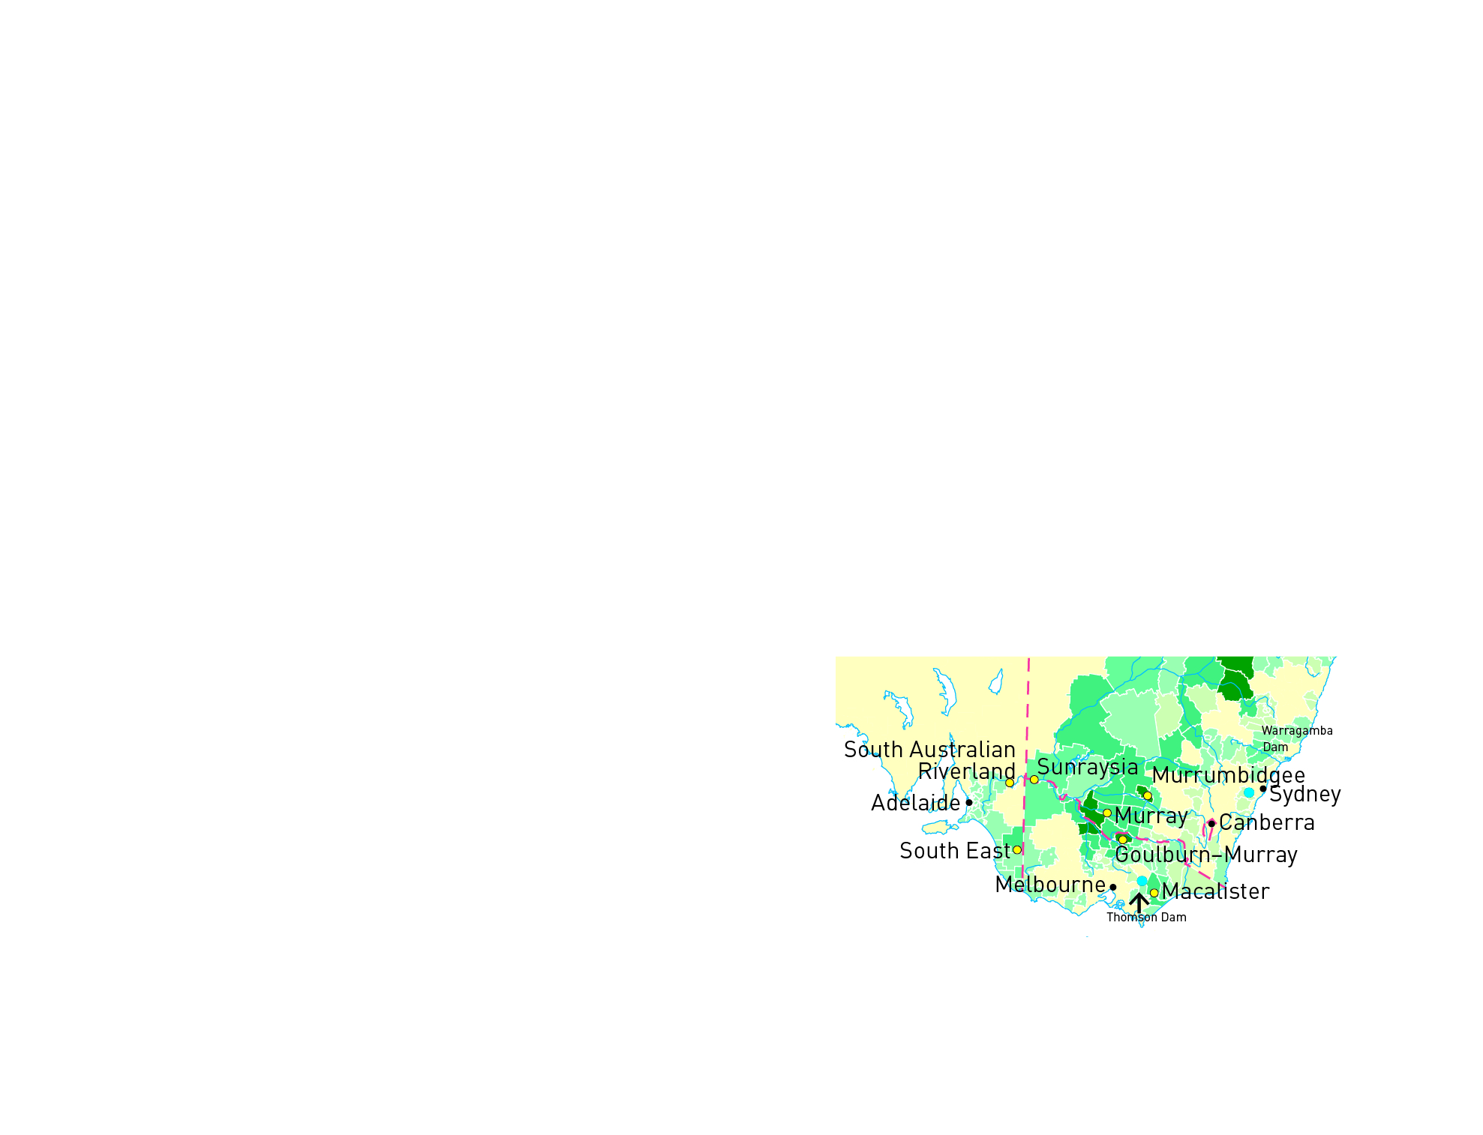

a Which city would use the Thomson Dam for part of its domestic water supply?

b Which city would use the Warragamba Dam for part of its domestic water supply?

WORD DETECTIVE

4 Match-a-word

Match the words to their meanings.

Agriculture An increase in the overall temperature of the Earth’s atmosphere

Industry A place that removes salt from sea water to get fresh water

Domestic Separation or purifying a liquid by heating or cooling

Global warming The manufacture of goods in factories

Distillation The watering of land ready for agriculture

Desalination plant Water held underground

Irrigation The practice of farming

Groundwater Occurring within a country

Literacy support worksheet

3.5 Water is a precious resource

Pages 56–57

There’s precious little water

1 If the world’s water was represented by a 1 litre (1000 millilitre) container, calculate the number of millilitres for the following categories:

a Salt water = 97.5% × 1000 mL = ________________________

b Fresh water = ________________________

2 The amount of water available per person on Earth is estimated to be 222 billion litres. Using Figure 3.19 in the textbook as a guide, complete the table below.

|  |  |  |
| --- | --- | --- |
| Location of water | Amount of water available per person (litres) | % Total water |
| Total water on Earth | 222 billion | 100 |
| Fresh water on Earth |  | 2.5 |
| Liquid (not frozen) fresh water on Earth |  | 0.75 |
| Fresh water in lakes and rivers |  | 0.025 |

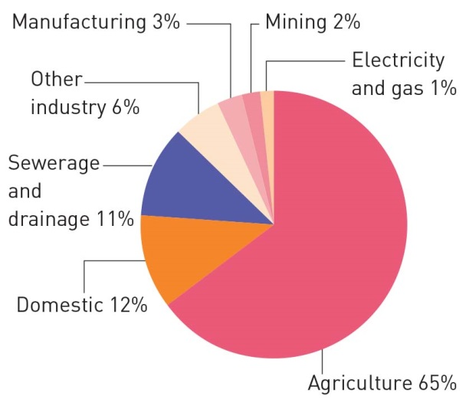

a Look at the pie chart on the right. What percentage of water is for domestic (personal) use?

b What percentage of water is used for agriculture?

c How does the amount of water for domestic use compare with the amount used for agriculture?

WORD DETECTIVE

3 True or false?

Read each statement below and circle T if it is true or F if it is false.

a Only 1.5% of Australia’s water is fresh T or F

b Only 0.007% of the Earth’s water is available for drinking T or F

c Most of the world’s fresh water is in groundwater T or F

d The price of water is increasing T or F